
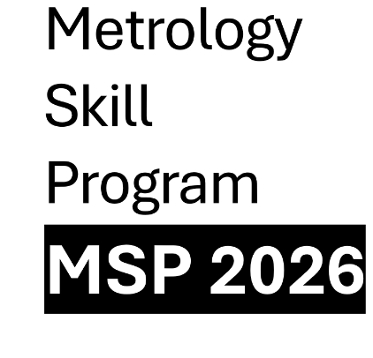

To: ​
Nik Marzuriani Nik Mohamed ​
Senior Consultant ​
Metrology Advisory and Support Group ​
National Metrology Institute of Malaysia
(NMIM) ​
Lot PT 4803, Bandar Baru Salak Tinggi, ​
43900 Sepang, Selangor Darul Ehsan. ​
Telephone: 603-87781695 ​
E-mail: nikmarz@nmim.gov.my

REGISTRATION FORM​

No.​ | MSP Title​ | Name of participant​ | Company​ | Designation​ | Email / Tel No​
​ | ​ | ​ | ​ | ​ | ​
​ | ​ | ​ | ​ | ​ | ​
​ | ​ | ​ | ​ | ​ | ​
​ | ​ | ​ | ​ | ​ | ​
​ | ​ | ​ | ​ | ​ | ​

